Standard Operating Procedure
Step-by-Step Workflow Documentation

Step 1: Step 1
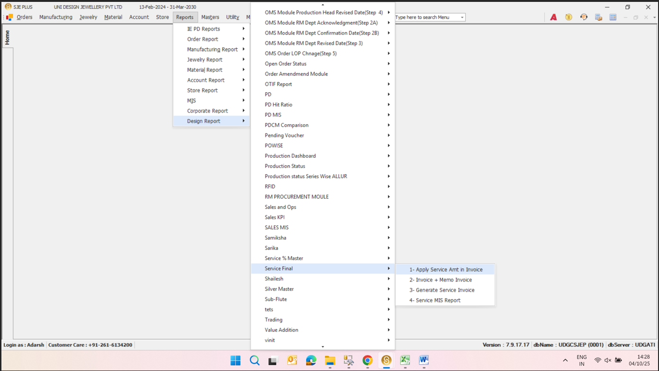
Design Report
Key objects & actions:
- Design Report —
- PD Hit Ratio —
- PD MIS —
- PDCM Comparison —
- Production Dashboard —
- Production Status —
- Production Status Series Wise ALLUR —
- RFID —
- RM PROCUREMENT MOULE —
- Sales and Ops —
- Sales KPI —
- Sales MIS —
- Service % Master —
- Shailesh —
- Samiksha —
- Sarika —
- Service Final —
- 1- Apply Service Amt in Invoice —
- 2- Invoice + Memo Invoice —
- 3- Generate Service Invoice —
- 4- Service MIS Report —

Step 2: Step 2
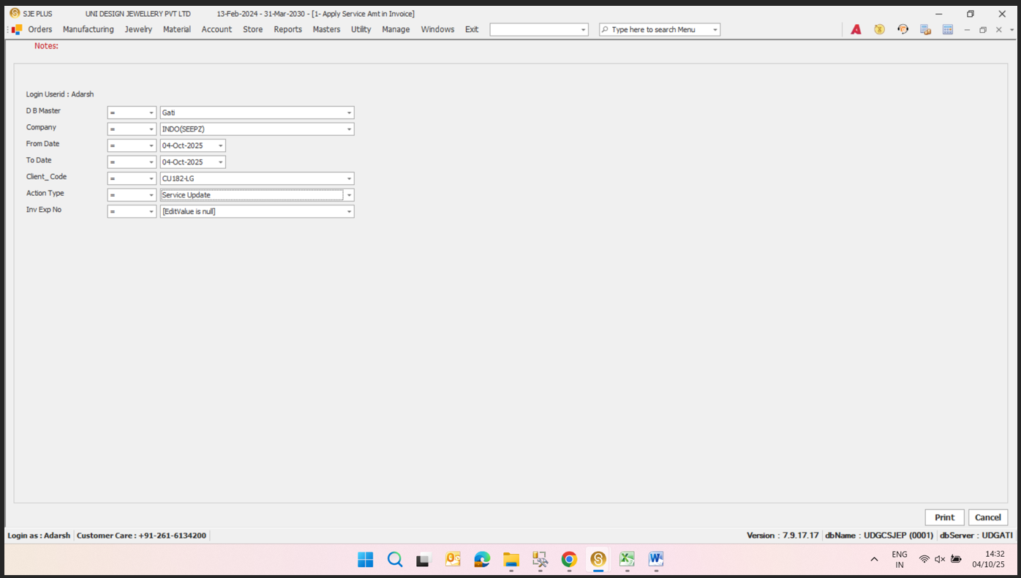
**Login and User Identification
Key objects & actions:
- **Login and User Identification — **
- **Database Master Selection — **
- **Company Selection — **
- **Date Range Selection — **
- **Client Code Selection — **
- **Action Type Selection — **
- **Invoice Export — **
- **Form Actions — **

Step 3: Step 3
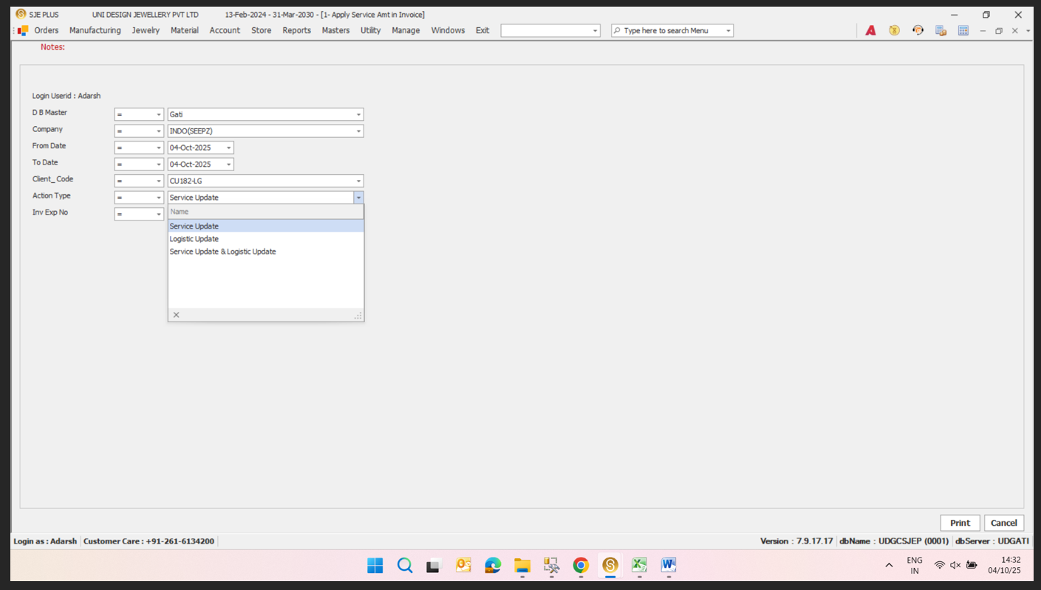
Service Update
Key objects & actions:
- Service Update —
- Logistic Update —
- Service Update & Logistic Update —

